Annual Examination [2023-24]
Class: XI [BIOLOGY] Date: 5/03/2024 Time: 3hours MM: 70
General Instructions:
All questions are compulsory.
The question paper has five sections and 33 questions. All questions are compulsory.
Section—A has 16 questions of 1 mark each;
Section—B has 5 questions of 2 marks each;
Section— C has 7 questions of 3 marks each;
Section— D has 2 case-based questions of 4 marks each;
Section—E has 3 questions of 5 marks each.
There is no overall choice. However, internal choices have been provided in some questions. A student has to attempt only one of the alternatives in such questions. Wherever necessary, neat and properly labelled diagrams should be drawn.
Section A
1. As we go from species to kingdom in a taxonomic hierarchy, the number of common characteristics
a) Will increase b) May increase or decrease c) Remain same d) Will decrease
2. Filtration of the blood takes place at:
a) DCT b) Glomerulus c) Collecting ducts d) PCT
3. Enzymes catalyzing in the link together of two compounds are
a) Ligases b) Lyases c) Hydrolases d) Isomerases
4. Upper surface of leaf is:
a) Abaxial epidermis b) Palisade parenchyma c) Mesophyll cell d) Adaxial epidermis
5.Which is the main organ of respiration in amphibians?
a) Lungs b) Skin c) Gills d) Both Skin and Lungs
6. Plants are known as purifiers of air due to the process of
a) Respiration b) Photosynthesis c) Transpiration d) Desiccation
7. That biomacro molecule of which all end products of metabolism can't be stored therefore processed for removal via excretion is/are
a) Proteins b) Vitamin c) Fats d) Carbohydrates
8. Whales can live in cold water as they have thick coat of
a) Keratinized skin b) Striated skin c) Blubber d) None of these
9. Growth can be measured in various ways. Which of these can be used as parameters to measure growth?
a) Increase in cell size b) All of these c) Increase in length and weight d) Increase in cell number
10. Some plants are dependent on the larger plant for space only. Such plants are called as
a) None of these b) Epiphytes c) Mesophytes d) Halophytes
l l .Excretory organs of body include:
a) Liver b) Lungs c) Sweat glands and sebaceous glands (d) all of these
12. Where does the exchange of gases take place in the respiratory system?
a) Bronchioles b) Alveoli c) Bronchi d) Pulmonary Artery
Assertion and Reason Type Questions:-
Instructions-
- Both A and R are true and R is the correct explanation of A.
- Both A and R are true but R is not the correct explanation of A.
- A is true but R is false.
- A is false but R is true.
13. Assertion (A): Sporangium is an asexual fruiting body found in Basidiomycetes.
Reason (R): Upper part of sporangium contains conidiophores
14. Assertion (A): A person has died because of carbon monoxide poisoning.
Reason (R): A person slept in a closed room with a lamp burning.
15. Assertion (A): Albumin is the most abundant protein.
Reason (R): Albumin is present in plants and animal both.
16. Assertion (A): Receptors associated with the aortic arch and carotid artery also can recognize changes in C02 and H concentration.
Reason (R): It sends necessary signals to the rhythm centre for remedial actions.
Section B
17. Mention the functions of cortex region of monocot root.
18. How does a gap junction facilitate intercellular communication?
19. Define the following:
(a)Exocrine gland (b)Endocrine gland
20. Write any three advantages of scientific names.
21. Cyano bacteria and some other photosynthetic bacteria don't have chloroplasts. How do they conduct photosynthesis?
Section C
22. What is the habitat of ferns. Describe their plant body. Explain the nature of spores ferns have. List out some common ferns.
23. Classify the following animals into phylum:
i. Honey bee ii. Duck iii. Prawn
24. Give any four steps involved in enzymatic catalytic action.
25. Growth is an important phenomenon of living. Justify the statement with reasons.
26. Given below is a diagram of different types of muscles. Based on the diagram answer the following questions:
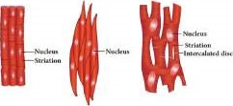
(a) Out of these muscles, which is closely associated with the skeleton?
(b) Why smooth muscle is regarded as visceral muscle?
(c) Muscles are typically arranged in antagonistic pairs. Give two examples.
27. Difference between Heartbeat and Pulse.
OR
Explain double circulation.
28. Enumerate the different types of nerve fibres according to their nature and function.
Section D
29. Read the text carefully and answer the questions:
The fungi constitute a unique kingdom of heterotrophic organisms. They show a great diversity in morphology and habitat. Fungi are cosmopolitan and occur in air, water, soil, and on animals and plants. They prefer to grow in warm and humid places. Most fungi are heterotrophic and absorb soluble organic matter from dead substrates and hence are called saprophytes. When a fungus reproduces sexually, two haploid hyphae of compatible mating types come together and fuse. In some fungi, the fusion of two haploid cells immediately results in diploid cells (2n). The fungi form fruiting bodies in which reduction division occurs, leading to the formation of haploid spores. Symbionts - in association with algae as lichens and with roots of higher plants as mycorrhiza.
Three types of reproduction «cur in fungi
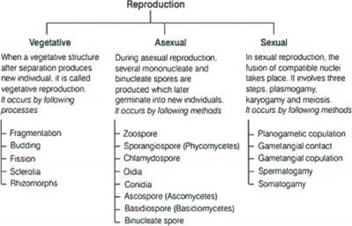
Observe the given flow chart of reproduction and mention which steps are involved in the sexual cycle of fungi.
OR
What is Rhizopus? Also, mention is “Rhizopus - wheat rust” a correct match?
What is Mycorrhiza? mention its function.
30. Read the text carefully and answer the questions:
The flower is the reproductive unit in the angiosperms. It is meant for sexual reproduction. A typical flower has four different kinds of whorls arranged successively on the swollen end of the stalk or pedicel, called thalamus or receptacle. These are calyx, corolla, androecium and gynoecium. Calyx and corolla are accessory organs, while androecium and gynoecium are reproductive organs. In symmetry, the flower may be actinomorphic (radial symmetry) or zygomorphic (bilateral symmetry). Based on the position of calyx, corolla and androecium in respect of the ovary on the thalamus, the flowers are described as hypogynous, perigynous and epigynous, A flower may be trimerous, tetramerous or pentamerous when the floral appendages are in multiple of 3, 4 or 5, respectively.
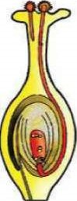
- Observe the diagram given below. and mention what happens after the given stage.
- Is Actinomorphic - datura the incorrect match?
- When the ovary is superior it is called?
OR
Which of the following represents epigynous? Also, mention what an epigynous flower is.
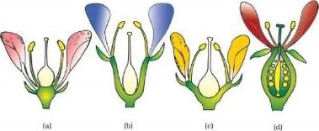
Section E
31. Comment on the statement - Meiosis enables the conservation of specific chromosome number of each species even though the process results in reduction of chromosome number.
OR
Explain meiosis-II in an animal cell.
32. Enumerate the assumptions that we have undertaken in making the respiratory balance sheet. Are these assumptions valid for a living system?
OR
Give the various steps involved in Glycolysis.
33. Describe the structure of the following with the help of labelled diagrams.
i. Nucleus ii.Centrosome
OR
Give the biochemical composition of plasma membrane. How are lipid molecules arranged in the membrane.

